**CIS515 - Final Project Report**

**Cohort B - Team 11 (Anurag Bhattacharjee, Dinesh Koonamakkal, Yash Jain, Jing Hao, Yugantika)**

**Topic Name - A Step Towards Sustainability**

**Part 1: Introduction**

1. **Problem Recognition**

In this project we are attempting to provide a viable solution which reinforces the concept of sustainability and renewable energy by incentivizing recycling of plastic. The use of plastic is prevalent in all fields of life. Governments have introduced measures to try and regulate the use of plastic, however, this has not led to its elimination from the market. Depleting fossil fuels and the carbon footprint they have has prompted the world to look for cleaner, alternate sources of energy. This proves to be a perfect marriage for our idea, recycling plastic to create solar panels for the generation of electricity. At present, majority of solar panels are made from silicon, glass, and plastic. Utilizing only recycled plastic can reduce the carbon footprint by 80% than the conventional solar panels and the panel themselves weigh much lesser than the conventional panels. This, in the long term have greater impact in the efforts towards a cleaner environment. Currently, the parking tariffs at ASU are quite high and create a financial burden on the students who use four-wheeler as a mode of transportation. This is a problem we are looking to create a solution for and incentivize to spread awareness regarding sustainable renewable energy generation.

1. **Status Quo**
2. **Renewable Energy Generation at ASU**

**Solar Energy**

ASU has more than 24-MWdc of photovoltaic (PV), concentrated photovoltaic (CPV) and solar thermal solar systems at 89 locations on all four of its campuses, the ASU Research Park, and off campus at the Red Rock Facility. These include fixed, single-axis and multi-axis tracker systems located on building rooftops, parking structures, surface parking and open land. Twenty-four MWdc capacity equals nearly 50 percent of ASU's present peak daytime load.

**Wind Energy**

ASU has mounted six wind turbines on the roof of the Global Institute of Sustainability building to provide an additional source of renewable energy. However, these are not completing 100% of the energy needs of ASU. There is a necessity for additional methods to generate renewable energy.

1. **ASU Parking Tariffs and Permits**

Exorbitant charges are a financial burden to anyone using the parking facilities.

**Parking Rates at Tempe campus**

|  |  |  |  |
| --- | --- | --- | --- |
| 1 hour or less | 1-2 hours | 2-3hours | 3 hours and more |
| $4 | $8 | $12 | $16 |

**Permit options:** $480-$780 (1year);

**Part 2: End-to-End Solution**

1. **Execution Approach**

Steps followed in the model execution:

* Take pictures of recyclable materials and collate all those pictures in a database.
* Create an object recognition CV model based on the data.
* Install cameras on the parking spots. When the camera takes pictures of the waste products, it uploads the data to a server and scans through the database. If there is a match, it provides parking credits already mapped to the objects in the database.
* The agent is then provided with the aggregate of the parking credits based on the number of items.
* The credits can be used as an alternative to cards/wallets as mode of payment for parking fees and the waste materials are used to create solar panels.

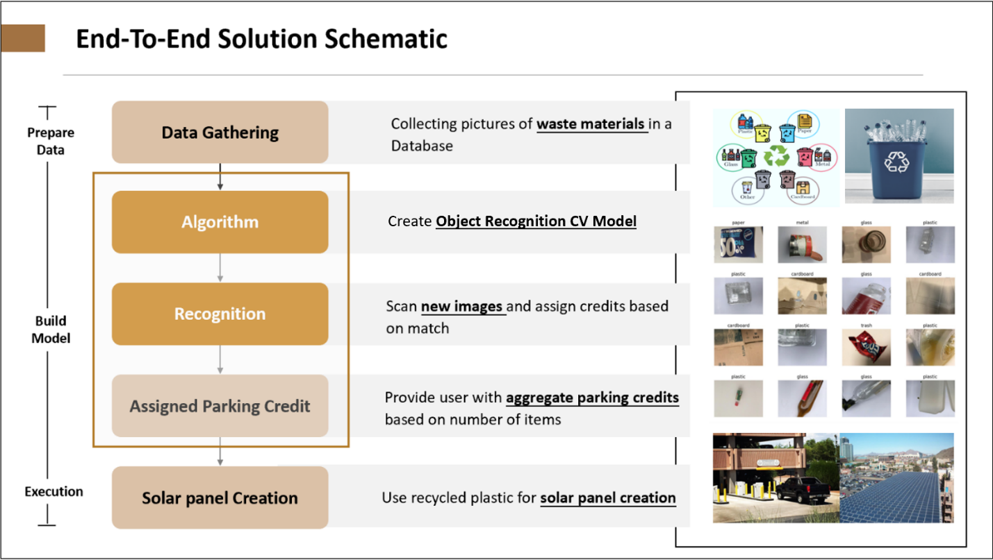

Figure 1 End-To-End Solution Schematic

1. **Scope of Solution**
2. **Key Stakeholders and Beneficiaries**

**Key Stakeholders**

* ASU Parking facility team- They are the direct stakeholder who would be responsible for managing the space available in the parking lot and oversee the credit distribution program generated via recycling the waste thrown in the recycling boxes
* Recycling Management Team- Who would be responsible to identify and segregate right type of recyclable material and generate credit points to be used later at the parking lot
* ASU community (including, staff, visitor and students) whose information is gathered and stored in the server
* Vendor/Supplier of Solar Panels who provides Solar panels to be used in the campus
* Company ‘X’ to which we would supply the recycled waste dumped in the recycling box
* UTO (University Technology Office) to monitor the chain of operations smoothly and troubleshoot in case of any hiccups or suspicious activities. Also, manage the installation of cameras and unexpected repairs.

**Beneficiaries**

This program is launched in the purview of bringing awareness for a cleaner and healthier environment by using clean methods of energy conservation and generation so everyone in the whole ecosystem would be benefitted. By launching this unique program, ASU would be a pioneer across the globe for maintaining its high standards for environmental conservation. This would catch the implicit attention of media houses to ASU and would publicize the ASU’s values towards making the planet cleaner and better every day, ultimately giving the admission seekers to study and research in the state-of-the-art facilities, and definitely making ASU a fine choice for their program selection. In monetary terms, this would be helpful for the ASU community (including, staff, visitor and students) who would be receiving credits for parking spaces just by dumping the recyclable material. This would encourage the existing ASU scholars to think and innovate for unique sustainable practices. Also, the people who would be a part of this program including the end user as well, would be more conscious of safe environmental practices and it would bring them a sense of achievement and satisfaction by contributing for a special cause.

1. **Value of Solution**

More than the monetary reason for launching this program, this is mainly focused towards a social cause, the approach speaks a volume about bringing an impact towards making the world a better place to live in and continuously progression towards a cleaner and safer environment. As we are moving towards extreme globalization and huge capitalism there exists an ever-growing and inexhaustible demand of energy and since we have limited resources available, we need to think of alternative solution to reserve essential resources for the future generations and progress towards a clean planet. We are taking the advantage of technology to implement this solution and spreading awareness among the masses for recyclability and solar power generation. This is long term solution for creating an ecofriendly environment and towards reaching sustainability goals. The program is worth of its value because of the consistent threat to the environment and unawareness among netizens. Based on the utility to its users, it would arise a sense of responsibility among its end users, for e.g., a sense of giving back to the society.

1. **Success Metrics**

Key points to monitor and analyze the performance of proposed solution:

* Successful registration and conversion of 60-70% vehicle owners to the active users of this recycling program
* Distribution of 10,000 credit points within first two months redeemable at the parking place

1. **Cost Estimation**

The estimated people, data, systems, and computational resources/costs would include:

|  |  |
| --- | --- |
| Hiring/Training (people) cost | $500 |
| Data Storage/Management cost: $0.023/GB  (AWS S3 database) | Around $2000 |
| System Installation cost: | $120 |
| Computational power consumption cost (based on average power consumption of a server i.e. 20.4 kwh) | $660/year |
| Solar-Panel cost | $25 per panel |

The estimated workflow updates/costs associated with this solution

|  |  |
| --- | --- |
| Increased storage cost: | $0.023/GB |
| System update cost: | Roughly $300 (This is the amount it takes to train a well performing Computer Vision model using cloud computing) |
| System Integration cost: | $100 (based on requirements) |

1. **Solution Validation, Monitoring and Update**
2. **Solution Validation**

**Pre deployment:**

* Detect if there is any data leakage. Remove duplicates before splitting the data, check for partial duplicates as well, sort by different columns, and examine the data.
* Check for drift in historical data. Train the model on historical data and then evaluate it on current data, if the results are significantly different from results on the historical data, we probably are experiencing data drift or concept drift.

**Post deployment:**

* Calibrate the model by updating the model so that not only the final predictions are accurate, but the probability estimate is accurate as well. This can be done by comparing the models’ predictions with the actual statistics of the appearance of each label conditioned on the features, and developing a new model from scratch.

1. **Solution Monitoring and Update**

Monitoring is important as models degrade over time with usage, known as model drift. Model Drift, also known as model decay, refers to the degradation of a model’s prediction power. Few Actions can be implemented:

***Action 1:*** Retrain the model with new data.

***Action 2:*** Retrain the model with additional features.

***Action 3:*** When the negative test accuracy is significantly high, repeat the process of feature extraction, then build, and train a new model from scratch.

1. **Possible Issues**
2. **Unexpected Incentives and Consequences**

The *first possible* unintended consequence is an incorrect estimate of incentive spent. Motivating students to participate in our program is challenging if the incentive spent is less. In contrast, the high incentive will cause the current plan to be less feasible. Therefore, based on our current strategy of reducing parking fees, we will develop a questionnaire to understand the impact of the amount and form of the incentive on student participation. Besides, we will weigh the overall expense and significance of the program to establish a highly viable incentive program.

The *second possible* unintended consequence is that the current activity reward is focused on reducing parking fee, but many students have not driven to school, which may affect their enthusiasm for their participation. Therefore, our project will gradually consider different types of incentives, expand the target group and improve everyone's enthusiasm for participation.

1. **Privacy and Security Issues**

This program has few privacy issues because the information involved only includes the participants' personal information and their activity records. However, we still pay great attention to privacy and security of the participants, such as not disclosing the participation records without the user's consent, and the participants cannot check the records of others.

1. **Related Work**

Firstly, solar panels are commonly used on college campuses. ASU is a solar energy leader, has the most solar energy of any college nationwide, and produces enough solar energy to meet nearly half of its peak daytime energy demand. Secondly, to move away from aluminum and glass in favor of plastic, some companies are experimenting with solar panels made of plastic. According to the reports, Solarge (A solar panel manufacturer) has released a product that replaces the glass of a solar panel with a plastic product, and it is producing the panel on a pilot line that it hopes to scale up by the end of 2022.Like the traditional application of solar panels on the ASU campus, our project's primary purpose is also to save energy and protect the environment by installing solar panels. The difference is that our solution is based on using solar panels made of plastic, rather than the traditional use of glass and aluminum solar panels. Besides, we also emphasize the active participation of all teachers and students, which facilitates the collection of more valuable plastics and help to build awareness of environmental protection.

1. **Scalability**

The solution can be tried out on a pilot basis around the campuses of ASU. With the abundance of sunlight round the year, this can be implemented in other parts of Arizona too, creating a sustainable model for production of energy without the necessity of allocating additional resources of land for this purpose. The light weight and durability of the panels created out of plastic make it a possible to be mounted on top of constructions too in accordance with the construction regulations.

**Part 3: Model Design**

1. **Using of CV**

In our project, computer vision plays an important role, which will be used for two image analysis tasks: *object detection* and *classification*. On one hand, we are using object detection techniques to complete the process of finding multiple objects in the images and also writing bounding boxes on top of the objects, which helps us to reduce the dimension of the image only to capture the objects and significantly improve the execution time. On the other hand, we are using classification techniques to classify if the object is plastic or not, to provide evidence for our next step of assigned credits and improve the collection efficiency.

1. **CV Model Description**

We can frame the waste classification problem as an image classification problem where we have a camera that takes an image of the waste and uses a deep neural network to identify what class the waste belongs to. Our CV model consists of Convolutional neural networks (CNNs) that use multiple hidden convolutional layers to extract high level features. This leads to a feature map of the filter, which is used to classify the images. The design of the model uses transfer learning to leverage knowledge from a source task. We used Resnet 18 as our pretrained model. Transfer learning can also provide a number of benefits, such as,

a) improving baseline performance,

b) speeding up overall model development and training time and

c) getting overall improved model performance compared to building the model from scratch.

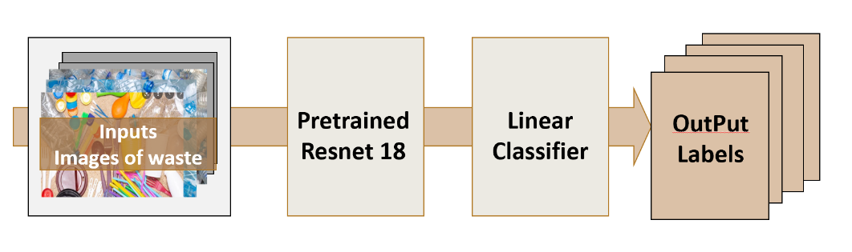

Figure 2 Model Schematic

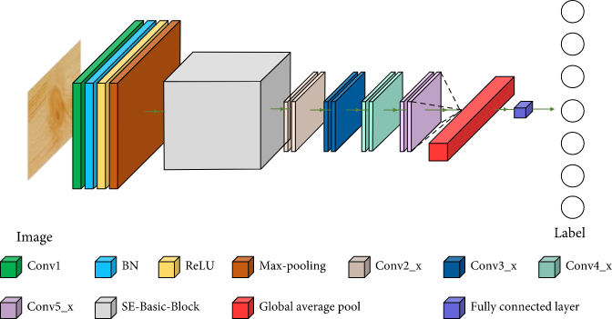

Figure 3 ResNet18 Model Architecture

1. **Model Training Details**

**Dataset:**

We used TrashNet Dataset to evaluate our model. The dataset contains multiple classes: plastic, paper, glass, metal, cardboard and other. It also contains a range of images of waste in different orientations and positions as seen in Figure 5. The original dataset is 3.5GB in size, containing 2527 images in total. The number of images in each class varies with 594 paper, 501 glass, 410 metal, 482 plastic, 403 cardboard and 137 for other materials. For the evaluation, the images are split into a train, validation and test set with a 70 (1768), 15 (379), 15(380) split.

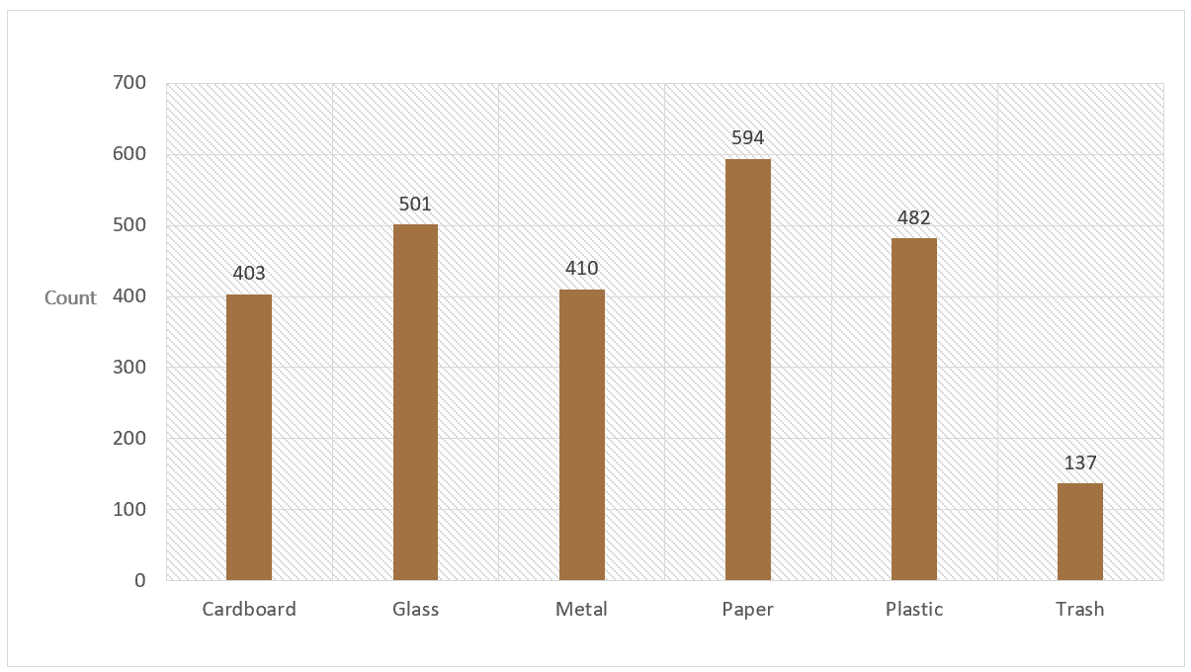

Figure 4 Dataset class balance

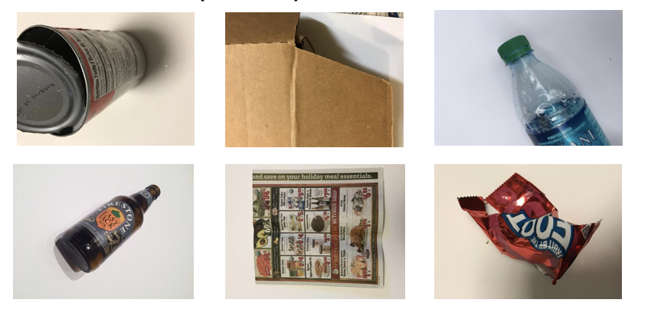

Figure 5 Object Classes

**Metrics:**

We use a number of classification metrics to comprehensively show how the classification models perform. The metrics are based on the number of True Positives (TP), False Positives (FP), True Negatives (TN) and False Negatives (FN) and are defined as:

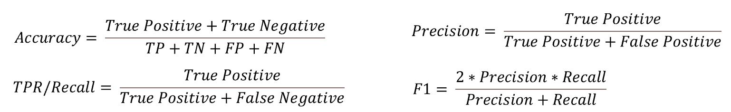

|  |  |  |  |  |
| --- | --- | --- | --- | --- |
| Model | Accuracy | Precision | Recall | F1 Score |
| ResNet18 | 0.93 | 0.93 | 0.93 | 0.93 |

**Confusion Matrix:**

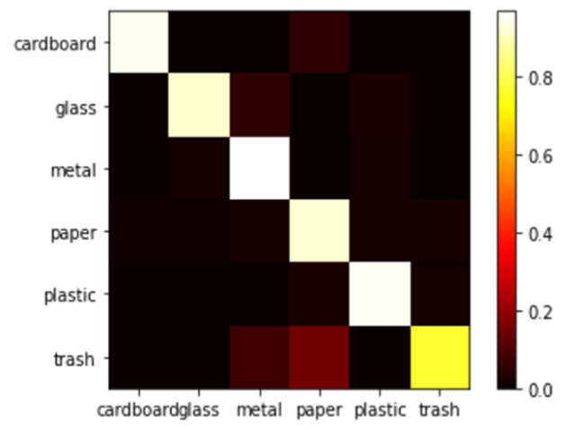

Figure 6 Confusion Matrix

Figure 6 shows the confusion matrix for our TrashNet approach on the test dataset. The y-axis shows the true labels and the x-axis shows the predicted labels. We can see that most of the labels have been correctly predicted as the middle top left to bottom right diagonal has most of the results. Overall, the model has achieved a good prediction accuracy of 0.930. However, we can also see the classes have been mislabeled in the confusion matrix. The most confused classification is predicting metal when the true label is glass, which happens 5 times. The second most confused classification is when the material is glass, but the prediction is plastic.

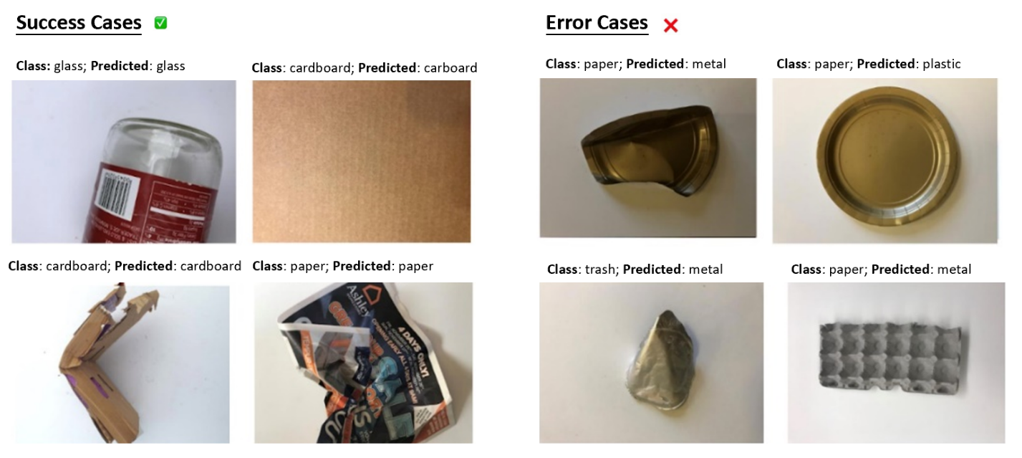

Figure 7 Examples of classification results

**Accuracy and Loss Plots:**

The blue line shows the network during training and the orange line shows the network during validation using specific learning rate. As seen, there is a lot of variation in the both the stages, when the network is beginning to classify the waste. We can see that accuracy in this stage varies a lot starting at around 0.93 and dropping to 0.90. Once the network begins to stabilize the accuracy at around 15 epochs the remaining layers are gradually unfrozen to allow for further accuracy improvement. After this increase the network accuracy remains quite stable.

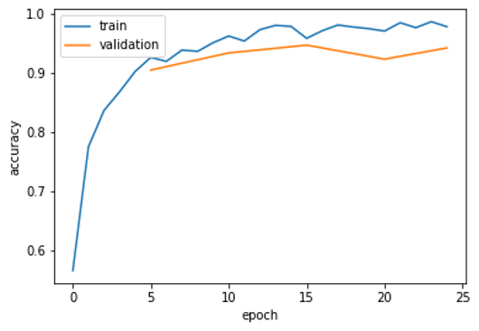

Figure 8 Accuracy Plot

Figure 9 shows the training and validation loss of the network as it is being trained. The orange and blue lines show the training and validation loss. We can see that during this period the loss function is high as the new top layer of the network is learning to classify the waste material. At around 15 epochs the loss value begins to stabilize and falls to a lower amount. After 15 epochs both the validation and training loss remain quite stable.

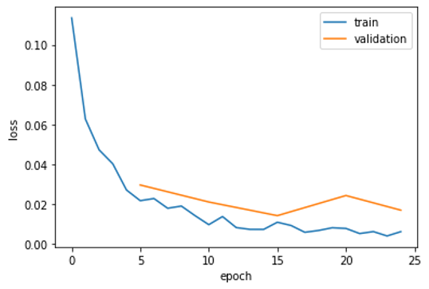

Figure 9 Loss Plot

1. **Model validation, Monitoring and Update**
2. **Model Validation**

**Pre deployment:**

* Detect if there is any data leakage. Remove duplicates before splitting the data, check for partial duplicates as well, sort by different columns, and examine the data
* Check for drift in historical data. Train the model on historical data and then evaluate it on current data, if the results are significantly different from results on the historical data, we probably are experiencing data drift or concept drift.

**Post deployment:**

* Calibrate the model by updating the model so that not only the final predictions are accurate, but the probability estimate is accurate as well. This can be done by comparing the models’ predictions with the actual statistics of the appearance of each label conditioned on the features and develop a new model from scratch.

1. **Monitoring and Update**

Monitoring is important as models degrade over time with usage, known as model drift. Model Drift, also known as model decay, refers to the degradation of a model’s prediction power. Few Actions can be implemented:

***Action 1:*** Retrain the model with new data.

***Action 2:*** Retrain the model with additional features.

***Action 3:*** When the negative test accuracy is significantly high, repeat the process of feature extraction, then build, and train a new model from scratch.

1. **Outcome Action Pairings**

The model would provide a count of the objects scanned by the class along with some data count by the manual segregation. To eliminate FP/FN we plan to have data both compared and analyzed to understand the pattern in which the model classifies incorrect and then train the model further to ensure that error is reduced.

|  |  |
| --- | --- |
| **Outcome** | **Action** |
| FP | Compare data from model and manual data and train model further |
| FN | Compare data from model and manual data and train model further |
| TP | Credits assigned to User |
| TN | Default credits assigned to user |

**Cost benefit analysis**

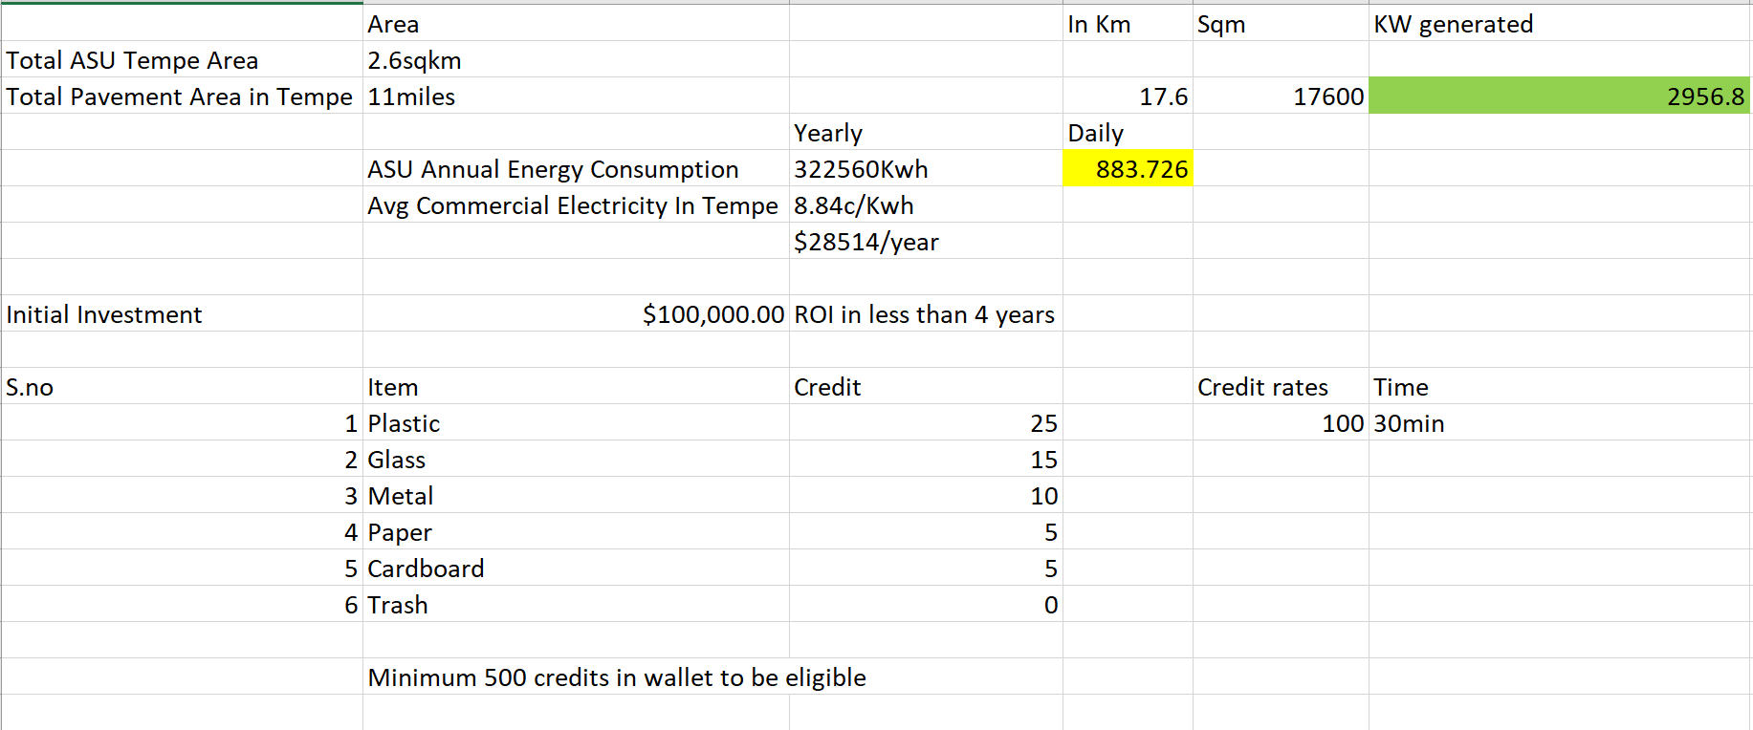

From a cost stand point, these actions would involve more computational and server requirements which incur incremental costs as per requirements. For the overall solution, there is initial investment required for processing and installation of cameras, waste bins and solar panels. However, the solar panels start generating a return on investment after 8-years. Solar panels generate electricity approximately 30% cheaper than utility electricity over their lifetime. Over 20 years, solar panel savings range from a low of $10,000 to over $30,000 costs. ($600 to $2,000 per year), depending on the location and the cost of electricity.

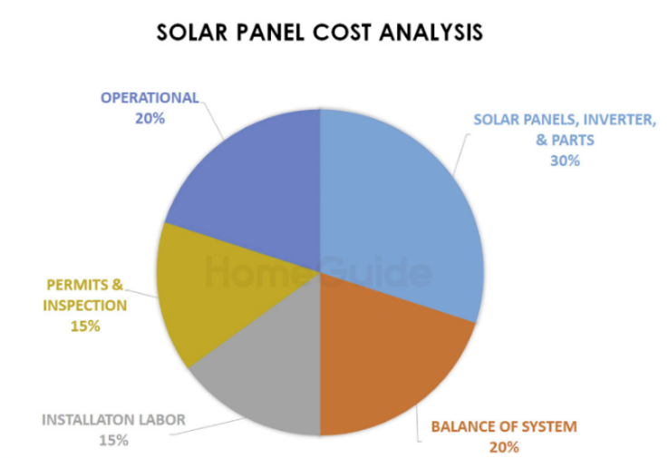

Figure 10 Solar Panel Cost

1. **Bias Issue and Mitigation Method**

**Bias issues**

* Model evaluation: Accuracy is lost when tested on a complex background.
* Feature: Incorrect prediction in some cases when trash has similar features irrespective of the material (transparency, color, shape, etc.)

**Methods to mitigate these bias issues**

* Using a bigger network i.e., more layers/nodes –both of which will increase number of model parameters
* Training longer with more iterations
* Using a faster/better optimization algorithm
* Using a different NN architecture

1. **Limitation and Mitigation Method**

**Limitations**

Some known limitations of the CV model are:

* The model is unable to evaluate the material weight and density which causes error in prediction when the material has similar features (transparency, color, shape, etc.)
* The model does not provide real time data labels.
* Imbalance size for one class.

**Methods to mitigate these limitations**

* Introducing more parameters to the model with additional features
* Using Integrate Object-Detection networks (YOLO) for real time object labeling.
* Using data augmentation or other ways to reduce class imbalance.

1. **Future Enhancements**

Some suggestions to improve the cost efficiency and provide better optimization on the existing model:

* Would like to extend the scope of credit point distribution beyond parking lot facility, for e.g., credit points usability in form of food coupons
* Along with the use of Computer Vision in capturing the image, and classifying the type of waste would like to add extensions in the recycling machine that would help to identify the recycling waste better and reduce the chance of detecting an object as False positive. For e.g., a weight machine which can weigh the object and detect the density of material to classify it more accurately.
* Separate segregators for each type of material being dumped into the recycle bin. As of now we are cumulating all the type of recyclable material at one single place but in the enhancement phase we would like to add a system which can automatically segregate the waste in the bin itself rather than manually separating the waste later
* Automatic alert would be raised to the recycling waste team to pick the waste collected and empty the recycle bin as soon as possible
* The recycling box would show updates about what item is missing and needed most and based on same credit point distribution algorithm would be changed for e.g., similar to surge pricing in Uber, so in our system if there would be too much glass bottles collected in the bin but to keep the waste homogenous the recycling box would show that it needs plastic bottles now and would double up the credit points for users who would submit plastic material now. This would convert a regular process into an engaging one and the users would be drawn to use the whole model more in comparison to general
* Giving alerts to users about their contribution, generating shareable E-certificates to give them a sense of pride and make them realize how their small step is making an impact. Basically, we are engaging the users and increasing customer engagement level to market the product aggressively
* Focusing on waste classification typically using video feeds
* We are planning to update our model and collect additional data to allow for the automatic classification of waste where objects may be overlapping
* Would like to use- Integrate Object-Detection networks (YOLO) for real time object labeling to have more general perspectives. Also, we can try a mix-match of the below given architectures for object detection.

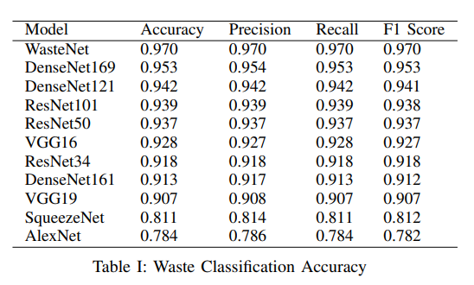

Figure 11 Waste Classification Accuracy

* Using datasets with more sophisticated data labeling and more data variations (instead of controlled data aggregation)
* Using Contrastive Learning is proved to be useful for classification.

1. **Scope Change**

The project is an extensive one and there are multiple stakeholders involved to accomplish this project, synergizing all stakeholders and assigning towards one common goal was a challenge while implementing this project. *So far, based on what we discovered, our scope has not changed.* Firstly, installing solar panels on campus is a well-established project. Secondly, use of solar panels made of plastic, which is emphasized in our project, is not yet widely available in the market, although manufacturers have started producing them. During the program's implementation, we will continue to observe the actual effect and feedback of the plastic solar panels in the market and the current incentive policy on the campus to adjust our scope. If required, we believe we can extend the scope to make it fully function and enhance its usability among its users.

**Part 4: Conclusion**

The results provide a number of interesting insights for future waste classification. The very high accuracy of 93% that we are able to achieve shows the potential of these methods. The models can be readily deployed in the waste bins at parking spots. This would increase the amount of waste being recycled, while also reducing the financial burden for ASU parking facility users by generating parking credits. The method can also be applied at large scale to automatically sort waste into different categories to allow for easier recycling.

**Part 5: Summary of Task Ownership and Contribution**

|  |  |
| --- | --- |
| **Tasks** | **Owner** |
| Problem definition | Dinesh |
| Scope and Requirement gathering | Jing |
| Data preprocessing | Yash |
| Model design and training | Anurag |
| Model validation | Anurag |
| Identification of Limitations and Surface issues | Yash |
| Cost benefit analysis | Dinesh |
| End to End Implementation and Feasibility Check | Yugantika |
| Report Creation | Jing |
| Presentation deck creation | Yugantika |

**Part 6: References**

**Code:**

<https://github.com/zubiamansoor/WasteNet>

**Others:**

<https://www.onaudience.com/resources/data-management-platform-pricing-and-buyers-guide/#:~:text=Even%20one%20data%20management%20platform,USD%20monthly%20(or%20more)>.

<https://environmenttexas.org/energy-101/campus-solar-energy>

<https://pv-magazine-usa.com/2021/10/25/plastic-for-solar-panels/>

<https://www.platiosolar.com/>

<https://www.designnews.com/alternative-energy/solar-harvesting-pavements-made-recycled-plastic>

<https://www.euronews.com/green/2021/09/14/this-solar-powered-pavement-harvests-energy-from-under-your-feet>

[Object Detection Algorithms - Computer vision | by Venkatakrishna Reddy | Analytics Vidhya | Medium](https://medium.com/analytics-vidhya/object-detection-algorithms-computer-vision-774cf0597c3b)